New API Token
Important
- Copy the API token below. Save to a secure place, as this API token will no longer be visible once this message is closed.
- Send the API token and documentation link below to your developers or third-party service providers.
- Anyone possessing this token can use the API to interact with the accounts you have permission to access.
API token: 9f28c036-1a99-40d5-9d37-390a96942d62
Copy Token
API Documentation: https://api-docs.velocityfleet.com/
Copy Link

Authentication
Authenticating with Radius Velocity requires two tokens: a Refresh Token, which you should have received from the Radius Velocity Portal, and an Access Token, which is used as a bearer token in the headers of every API request.
Always keep your Refresh Token safe and delete it if you suspect it has been compromised.
Generate Refresh Token
A Refresh Token is associated with only one product. If you need access to another product, you must generate a new Refresh Token. Be sure to inform the third-party service provider or developer which product the Refresh Token was created for.
Refresh Tokens that are not accessed within 30 days of creation will be automatically revoked. Refresh Tokens that have not been accessed for over a year will be revoked.
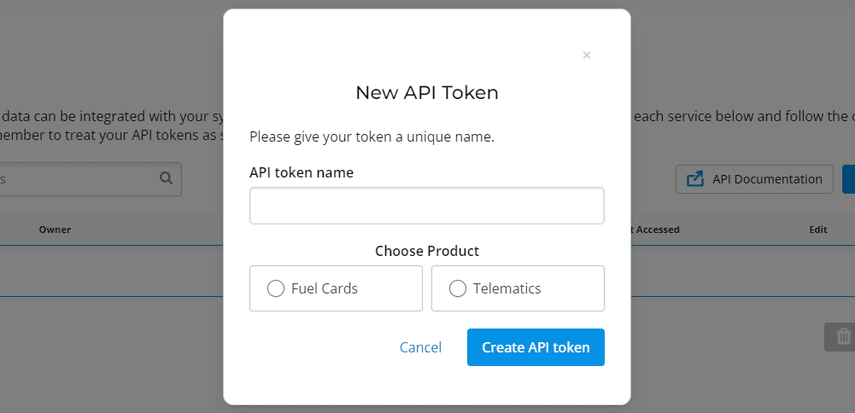
POST/vapi/v1/accounts/users/oauth2/refresh/

Generating Access Token
Once you have received the Refresh Token, you need to generate an Access Token. The Access Token can be generated by sending a POST request to the endpoint with the Refresh Token. The Access Token will expire every 30 days, so you will need to generate a new one after it expires.
After the Access Token is generated, you can use the Radius Velocity APIs.
Request
POST
/vapi/v1/accounts/users/oauth2/refresh/
curl --location --request POST
https://www.velocityfleet.com/vapi/v1/accounts/users/oauth2/refresh/
--form 'token=":refresh_token"'
CopyCopied!
Response
{
"token": "xxxxxxxxxxxxxxxxxxxxxx"
}
CopyCopied!
© Copyright 2026. All rights reserved.

Errors
In this guide, we will talk about what happens when something goes wrong while working with the API.
You can check if your request was successful by checking the status code in the API response. If a response is unsuccessful, you can use the status code, error type, and error message to identify the issue.
If you encounter an error while using Radius Velocity APIs and need to report it, please have your Radius Velocity customer contact the service desk with the following details: the timestamp of the error, status code, error code, error message, and the detailed steps taken to reproduce the error.

Status codes
Below is a list of the different categories of status codes returned by the Radius Velocity API:
- Name
200
Description
A 200 status code indicates that the request has succeeded. You should have received the requested data.
- Name
201
Description
A 201 status code indicates that the request has succeeded and a new object has been created.
- Name
204
Description
A 204 status code indicates that the request has succeeded, but no object is returned. You will receive this status code for DELETE requests.
- Name
400
Description
A 400 status code indicates a bad request.
- Name
401
Description
A 401 status code indicates that the user has not been authenticated. This code could be returned for several reasons. The error message will specify the issue.
- Name
403
Description
A 403 status code indicates that you do not have access rights to request the object.
- Name
404
Description
A 404 status code indicates a the requested object was not found.
- Name
405
Description
A 405 status code indicates that the HTTP method is not allowed for the particular endpoint.
- Name
500
Description
A 500 status code indicates a server error. The error message will give you further information about the issue.
- Name
502
Description
A 502 status code indicates a gateway timeout.
Load less
© Copyright 2026. All rights reserved.

Device Positions
The Device Positions API provides a simple interface to retrieve Telematics device position information for all available devices. This API allows you to retrieve a single device position as well as list all device positions. You can also filter device positions by using certain query parameters.
Device Positions model
The Device Positions model contains all the information about your device positions, such as device, location, ignition, and speed data. It also contains information about the device groups and the driver groups.
Properties
- Name
show_marker_reg_text
Type
boolean
Description
User preference to show/hide vehicle registration.
- Name
driver_groups
Type
array of objects
Description
The driver group the driver belongs to
- Name
device_groups
Type
array of objects
Description
The device group the Telematics device belongs to.
- Name
devices
Type
array of objects
Description
List of Telematics devices owned by the customer.
- Name
iso_numbers
Type
array of integers
Description
The ISO part of this card's PAN. This card's card pack reference number (multi-brand customer).
- Name
device_count
Type
integer
Description
The total number of Telematics devices.
- Name
kinesis_core_customer
Type
boolean
Description
Indicates if the customer is a Kinesis core customer.
- Name
eroute_url
Type
URL
Description
Eroute URL.
- Name
KINESIS_LIVE_MAP_REFRESH_RATE
Type
integer
Description
The map refresh rate.
- Name
KINESIS_LIVE_MAP_LARGE_FLEET_REFRESH_RATE
Type
integer
Description
The map refresh rate when the number of Telematics devices is high.
Load less

POST/api/mobile/kinesis/device-live-positions/?customer=:customer_id
List all Device Positions
This endpoint allows you to retrieve a list of all your device positions.
Required attributes
- Name
customer
Type
string
Description
Unique identifier for the customer you want device positions to be returned.
Request
POST
/api/mobile/kinesis/device-live-positions/?customer=:customer_id
curl -G https://www.velocityfleet.com/api/mobile/kinesis/device-live-positions/?customer=:customer_id \
-H "Authorization: Bearer {token}"
CopyCopied!
Response
{
"show_marker_reg_text": true,
"driver_groups": [
{
"id": 0,
"name": "Example",
"color": "#009DD1",
"devices": [],
"type": 3
}
],
"device_groups": [
{
"id": 99999,
"name": "Example",
"color": "#EB9393",
"devices": [
{
"id": 99999,
"mobile_phone": null,
"private": false,
"lat": 99.9999999,
"lon": -9.9999999,
"driver_name": "Joe Bloggs - Mitsubishi",
"driver_name_list_display": "Joe Bloggs - Mitsubishi",
"previous_driver": "",
"vehicle_registration": "AB12 ABC",
"service_id": "1234abcd-12ab-12ab-12ab-123456abcdef",
"driver_id": "",
"ignition": "Y",
"speed": 0,
"speed_measure_text": "MPH",
"direction": 317.0,
"street": "A999",
"town": null,
"country": "United Kingdom",
"post_code": "XX1 1XX",
"device_groups": [99999],
"groups": [99999],
"group_color": "#EB9393",
"driver_groups": [],
"device_group_color": "#EB9393",
"time": "14:16 </br> 13/09/2024",
"signal_strength_color": "green",
"timestamp": "1726233388",
"driver_group_color": "#288ecd"
}
],
"type": 2
}
],
"devices": [
{
"id": 99999,
"mobile_phone": null,
"private": false,
"lat": 99.9999999,
"lon": -9.9999999,
"driver_name": "Joe Bloggs - Mitsubishi",
"driver_name_list_display": "Joe Bloggs - Mitsubishi",
"previous_driver": "",
"vehicle_registration": "AB12 ABC",
"service_id": "1234abcd-12ab-12ab-12ab-123456abcdef",
"driver_id": "",
"ignition": "Y",
"speed": 0,
"speed_measure_text": "MPH",
"direction": 317.0,
"street": "A999",
"town": null,
"country": "United Kingdom",
"post_code": "XX1 1XX",
"device_groups": [99999],
"groups": [99999],
"group_color": "#EB9393",
"driver_groups": [],
"device_group_color": "#EB9393",
"time": "14:16 </br> 13/09/2024",
"signal_strength_color": "green",
"timestamp": "1726233388",
"driver_group_color": "#288ecd"
}
],
"iso_numbers": [789672, 706405],
"device_count": 20,
"kinesis_core_customer": true,
"eroute_url": "http://www.erouteonline.com",
"KINESIS_LIVE_MAP_REFRESH_RATE": 30000,
"KINESIS_LIVE_MAP_LARGE_FLEET_REFRESH_RATE": 90000
}
CopyCopied!
© Copyright 2026. All rights reserved.

